DTSC-540
Module 2 – AI Theory and Key Concepts
Required Reading:
Chapter 1 and Chapter 3 of You Look Like a Thing (Chapter 2 is optional)
https://ai-2027.com/
Voss, P., & Jovanovic, M. "Why We Don't Have AGI Yet"
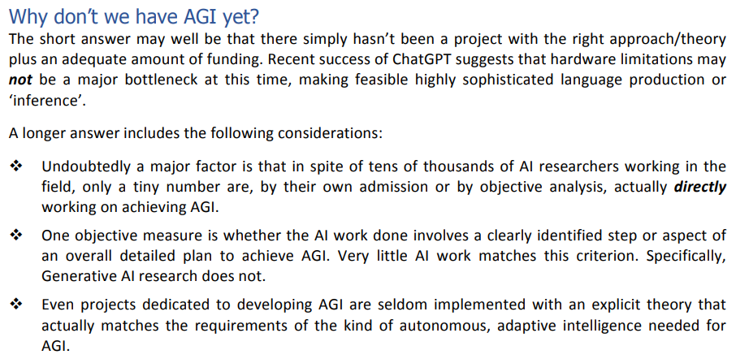
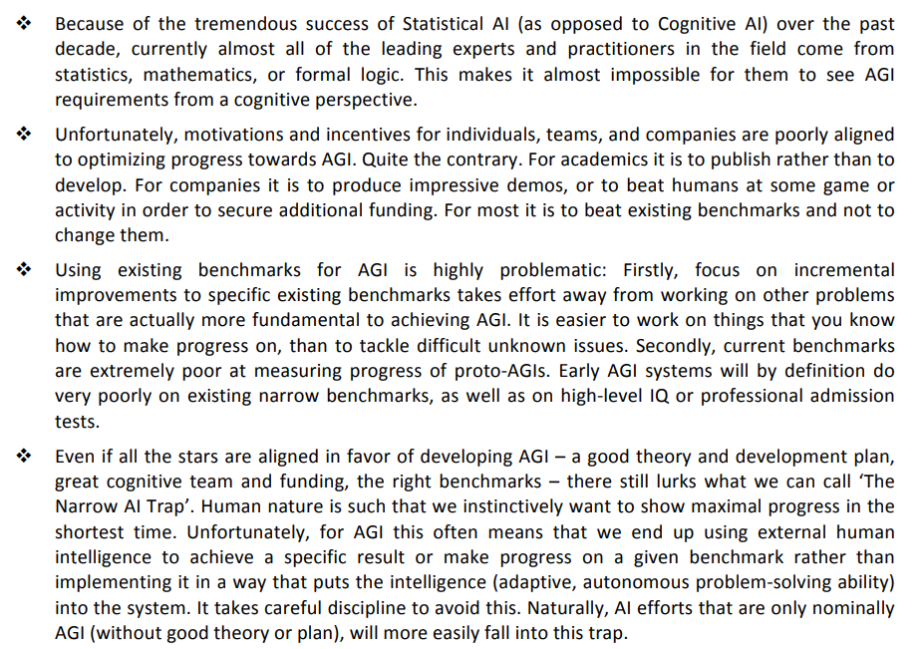

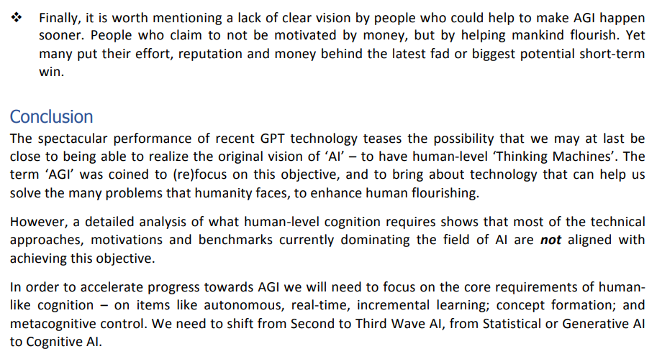
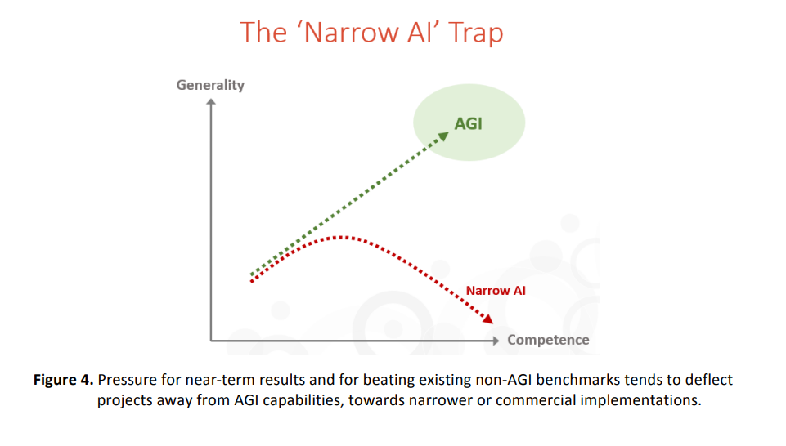
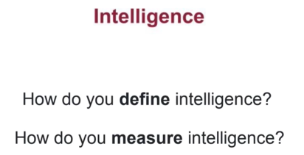
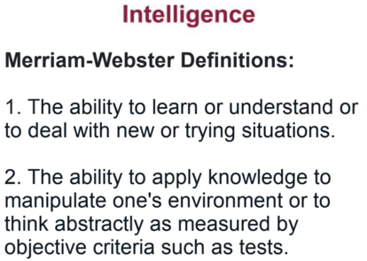
These are not very good definitions
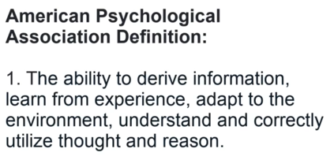
This lacks operational specificity
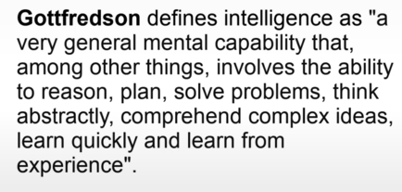
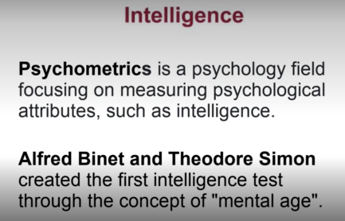

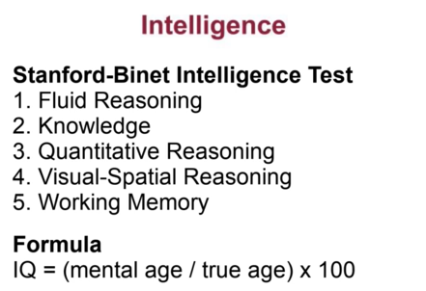
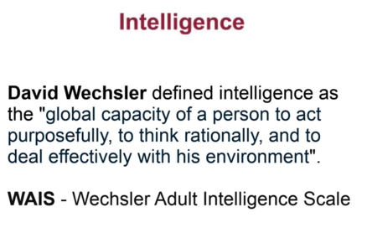
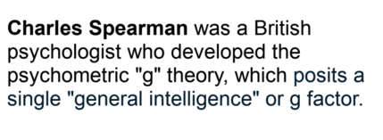
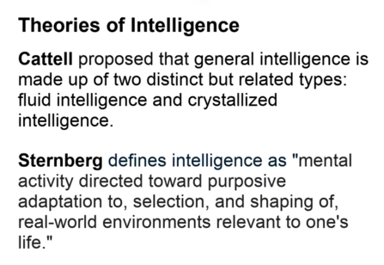
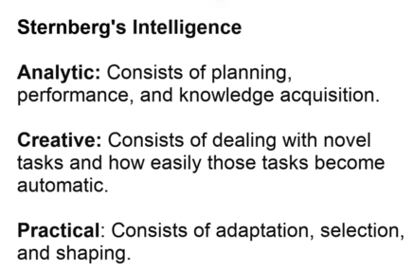
what-is-artificial-general-intelligence-agi
what-is-ai
what-is-generative-ai
what-is-deep-learning
what-is-prompt-engineering
what-is-machine-learning
what-is-tokenization
*** QUIZ TOPIC https://ai-2027.com/ ***
https://waitbutwhy.com/2015/01/artificial-intelligence-revolution-1.html

